Financial Reporting Form Instructions
2019
What’s inside?
- Changes for the 2019 Form and Process………Page 2
- Instructions for Financial Reporting Form…….Page 2
- Instructions to submit data online……………….Page 3

Changes for the 2019 Form and Process

In the past, sites were required to complete a Financial Reporting Form, and to email that form to CEA with supporting documentation. There was one Financial Reporting Form for all site types. A couple of years ago, an Excel version of this document with automated calculations was used for most sites. Last year, the process included updated instructions (this document) and an online submission form for the financial reports. The instructions have one form in Word, with no automatic calculations made. The new process asked sites to enter selected data into an online form and attach supporting documentation. There continues to be one Financial Reporting Form for all site types.

This year, there are no significant changes.

Instructions for the Financial Reporting Form

Gather the documents listed below for the last full fiscal year:

1. Balance Sheet
2. Revenue and Expenditures (Profit and Loss) Statement
3. Budget document
4. Other relevant financial documentation

Gather the documents listed below for the next full fiscal year:

1. Budget document

For multi-sites, there are two options for completing the Financial Report for multisite programs and institutions.

If accounting is done locally, submit financial data online for each site.
If accounting is done centrally, submit financial data one time online for all sites.

Fill out the online Financial Reporting Form for your site(s) and attach supporting documentation. After clicking the submit button, a receipt confirmation and a copy of the submission will be emailed to the email address indicated.
Financial Reporting Forms must be submitted by on February 15, 2019.

Instructions to submit data online
CEA will host a webinar on December 5, 2018 at noon to review the Annual Report package requirements for accredited sites. The webinar recording will be published at www.cea-accredit.org/resources. Additional Q&A webinars will be announced. Using the online form (pictured below), sites are requested to enter the information.
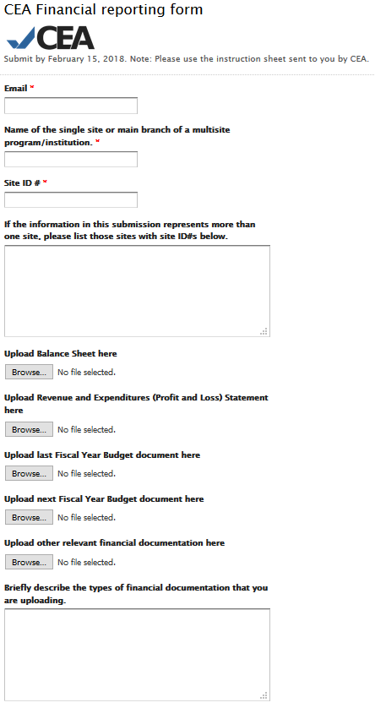
Responses to this form, including a confirmation email, will be sent to this email address.
Sites can find their Site ID# on CEA’s list of Accredited Sites. www.cea-accredit.org/accredited-sites
