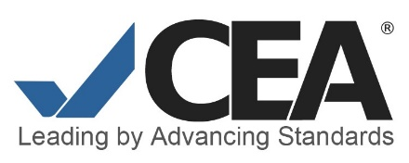
Guidelines for Creating a Profile
CEA Annual Report Portal

CEA Staff will approve the profile for the primary CEA contact on record for each accredited program or language institution. To authorize additional users, the primary contact should send a request by email including the site ID, user’s full name, title and email address to AnnualReport@cea-accredit.org.

Step 1. Use a web browser and navigate to carp.cea-accredit.org.
Step 2. To set up your profile, first click sign up. On the Sign Up page, fill out the form. Click the Sign Up button to submit your profile request.
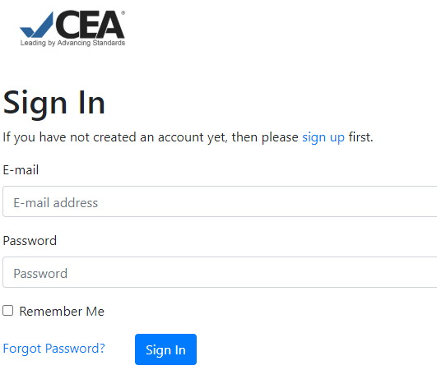 | 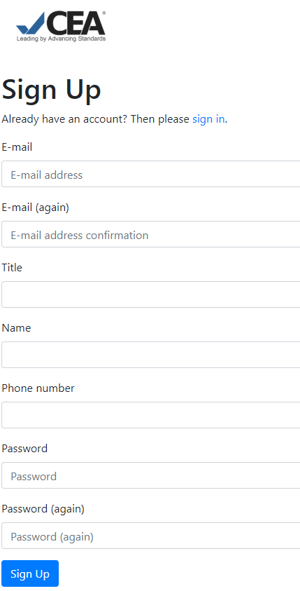

Step 3. After your profile request has been submitted, check your email and verify your email address with the annual report portal. The message will come from no-reply@cea-accredit.org and contain a link to carp.cea-accredit.org. Please check your junk or spam folders before contacting staff at AnnualReport@cea-accredit.org.
Step 4. After you have verified your email address by following the link, CEA staff will activate your account and connect it to your site. You may see a “Server Error (500)” if you attempt to explore the portal before your profile is connected to your site.
If you are the primary CEA contact, your profile will be approved. If you are not the primary contact in CEA’s records, approval from the primary CEA contact is required before your profile can be approved.

If you need more than one account for your site, the primary contact must request additional accounts by providing the site name, site ID, individual’s name, role/title, and email associated with the account at AnnualReport@cea-accredit.org. All requests for CARP accounts made by the CEA primary contact will be approved. If you need to change the primary contact, send an email to info@cea-accredit.org.
Each user profile will need to be set up using the same process.

