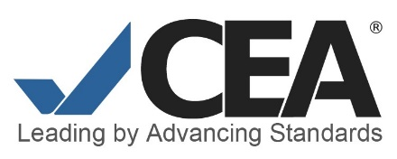
Letter of Understanding and Agreement to Serve—Commission Nominee

CEA commissioners have special obligations to enhance the nature and integrity of the accreditation process, including policy maintenance, standard review, decision-making, and general oversight for the accreditation program. Therefore, as a nominee to serve on the Commission and in recognition of the importance of the accreditation program to the profession, it is necessary that you agree to the following:

General responsibilities

- You will serve for a period of up to three (3) years and attend and actively participate in up to three (3) Commission meetings of no more than four (4) days duration.

- You will be an ambassador and advocate for the accreditation program within the appropriate professional associations and the larger community concerned with English language acquisition.

- You hereby assign to the Commission all right, title, and interests in and to any information or material developed, conceived, or created relating to the CEA program, including any and all copyrights.

Accreditation reviews

- You will serve as a member of the Commission’s subgroups which will be expected to function both during regular Commission meetings as well as between such meetings and will adhere to timelines/deadlines for individual and group work.

- You will not disclose or cause to be disclosed to anyone other than the Commission or authorized CEA staff any confidential information related to the accreditation program or the program or institution subject to the specific review or investigation at hand and will not disclose the contents of confidential deliberations to anyone, except upon order of CEA.

- You will keep all confidential information in a safe and secure place, such as a locked file, and will take all reasonable steps to protect against inadvertent disclosure or theft of the information. After evaluation of any program or institution under consideration for accreditation or re-accreditation, you will destroy all materials you have that are relevant to the accreditation decision, including electronic files.

Conflict of interest

- You will not engage in actions that may constitute an actual, apparent, or potential conflict of interest with the mission and activities of CEA. With the signing of this Agreement, you agree to recuse yourself from reviewing any program or language institution with which you have a current or former relationship, including but not limited to acting as a consultant, serving as a site reviewer, or having a business, financial or organization interest or affiliation.

Personal representation

- If elected, during your term of service as a commissioner, you will not in a false, misleading or deceptive manner reference your participation with respect to CEA, nor will you, except as authorized by CEA, consult with English language programs or institutions seeking accreditation on the topic of CEA accreditation or give presentations on the topic of CEA accreditation. If you serve as a consultant for any English language program or institution in any capacity, you will inform CEA immediately.

Failure to fulfill any of the above obligations may result in removal from the Commission. CEA expects that for a period of at least 2 years following the end of your service, you will not be directly involved in any consulting work or other employment by or for a program or institution that you have been charged with reviewing.

Please sign, and return to CEA.

______________________________________ ____________________
Commission nominee Date

